Spring REST using Spring Boot 3

2.Spring-Rest-hands-on
Name: NALLANI LOKAKALYAN
Registered Mail: 2300030853cseh1@gmail.com

Hello World RESTful Web Service:

HelloController.java:
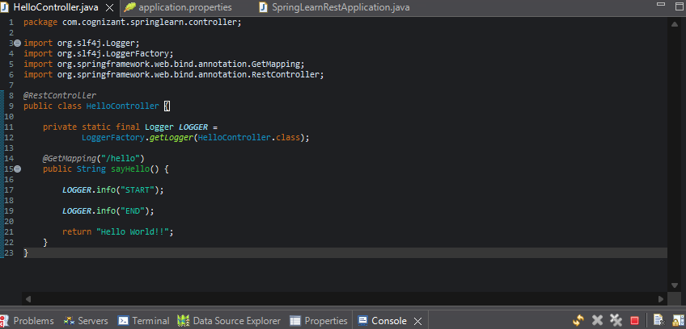

Application.properties:
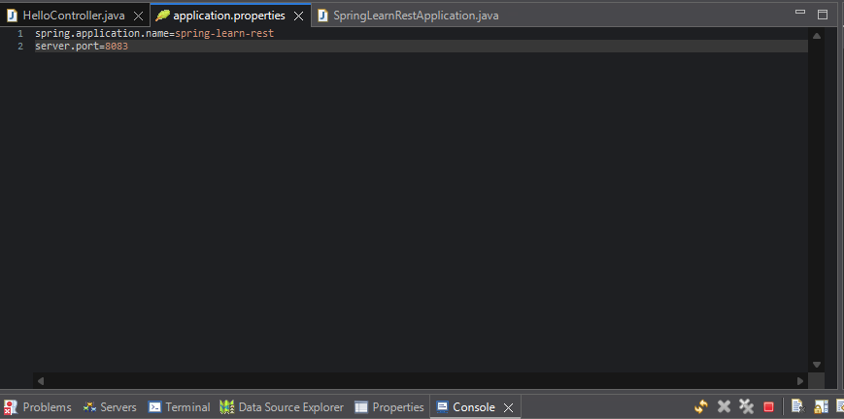
SpringLearnRestApplication.java:
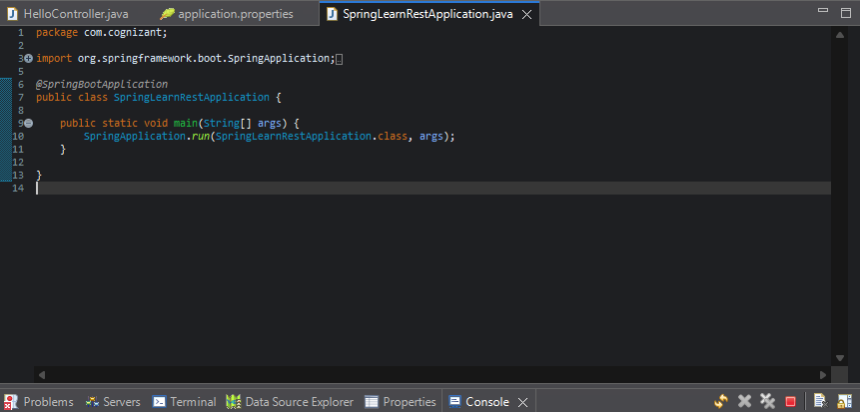

Output:
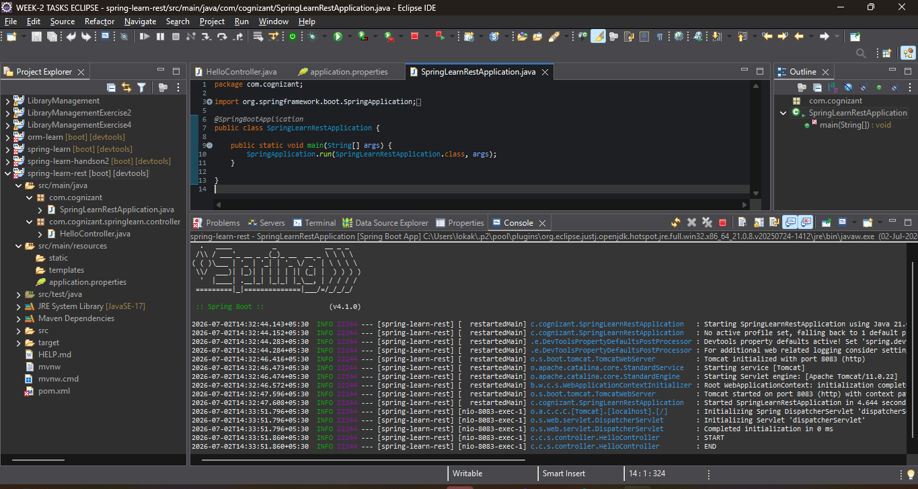
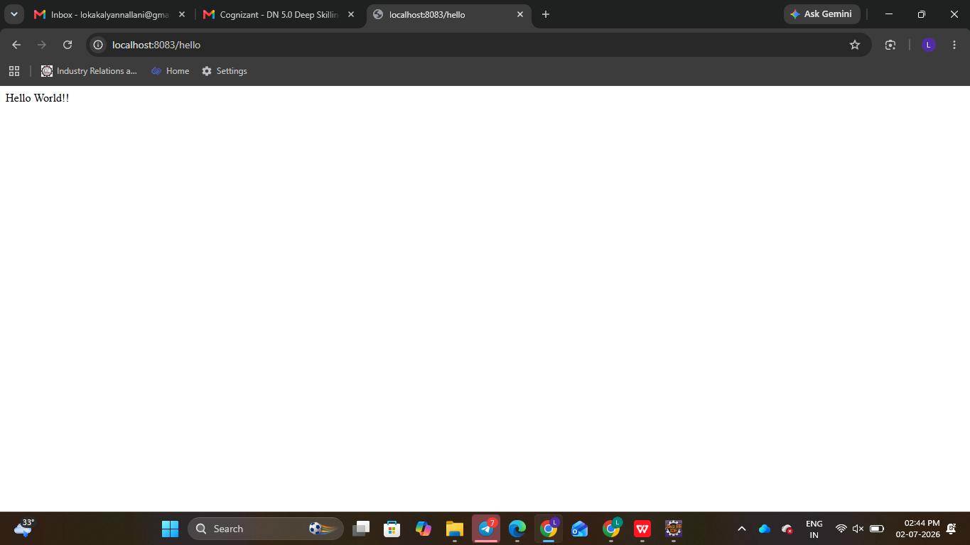
REST - Country Web Service:

SpringLearnCountryApplication.java:
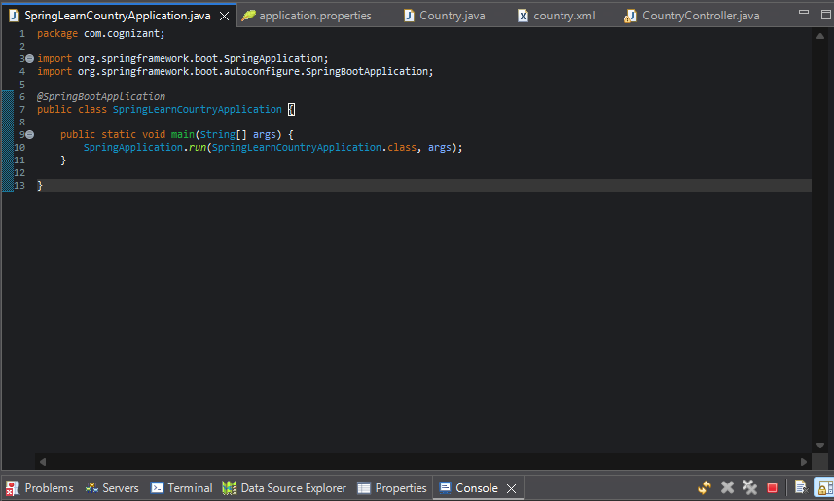
Coutry.java:
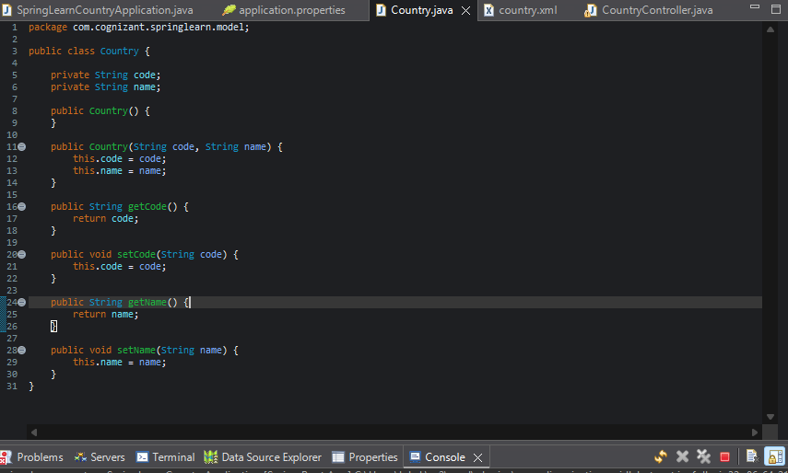
Application.properties:
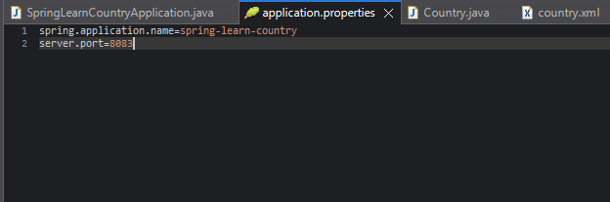
Country.xml:
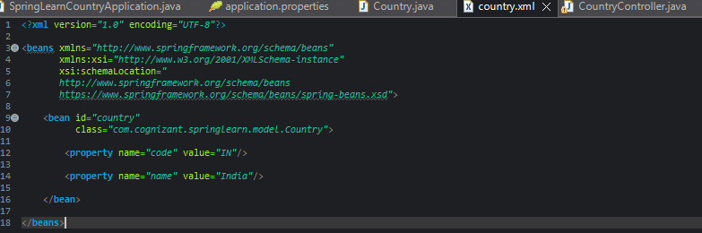
CountryController.java:
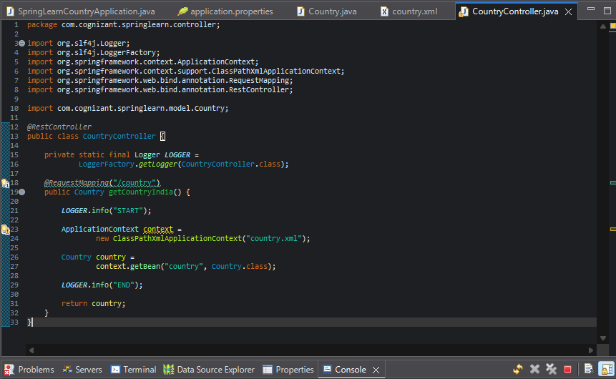
Output:
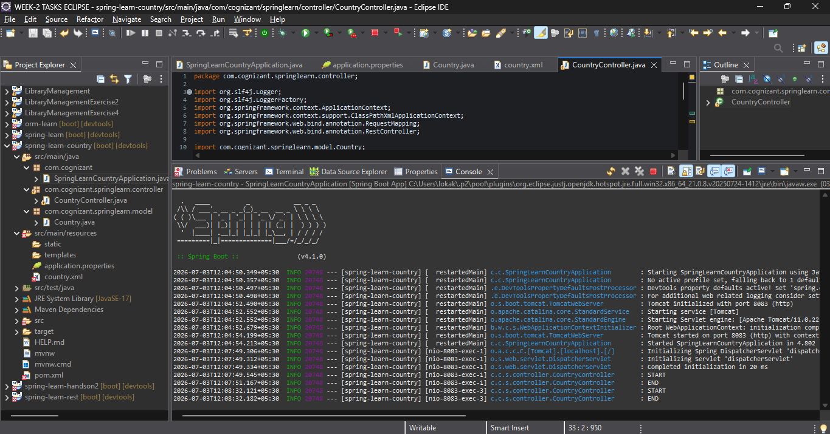

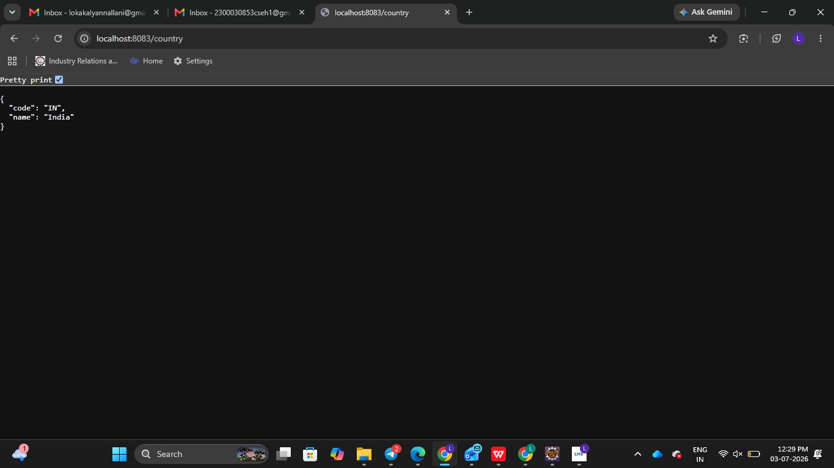

REST - Get country based on country code:
SpringLearnCountryCodeApplication.java:
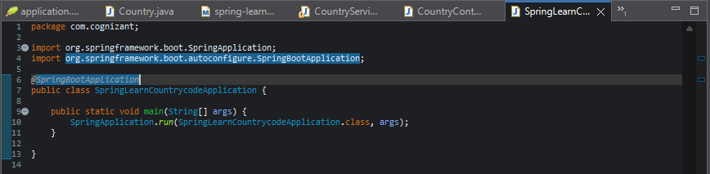
Country.xml:
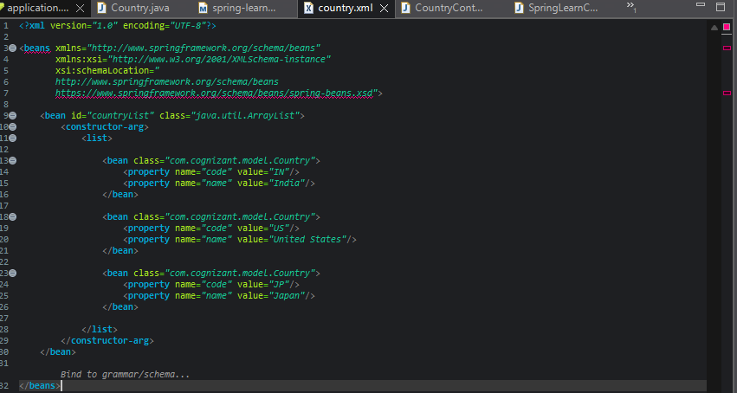
SpringLearnCountryCode/pom.xml:
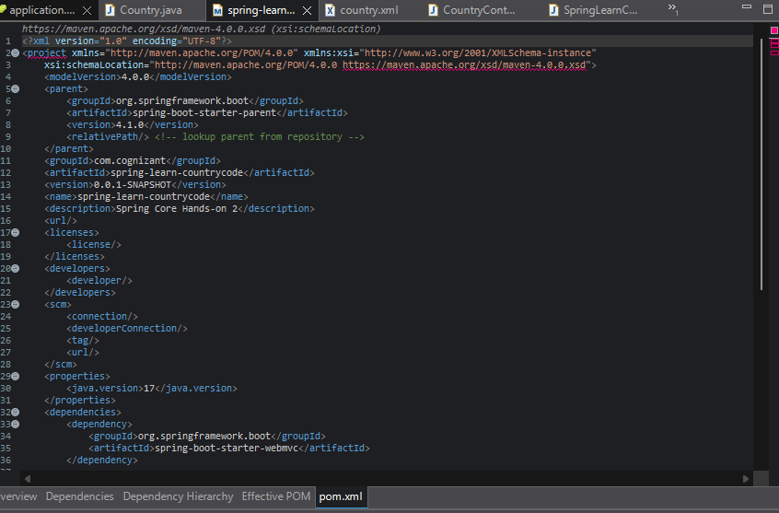
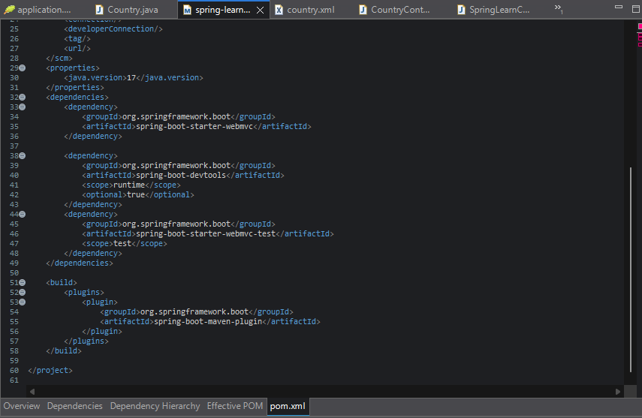
Application.properties:
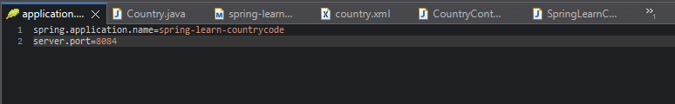
CountryController.java:
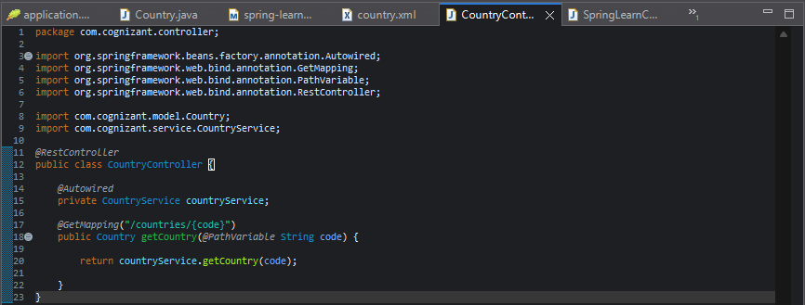
Country.java:
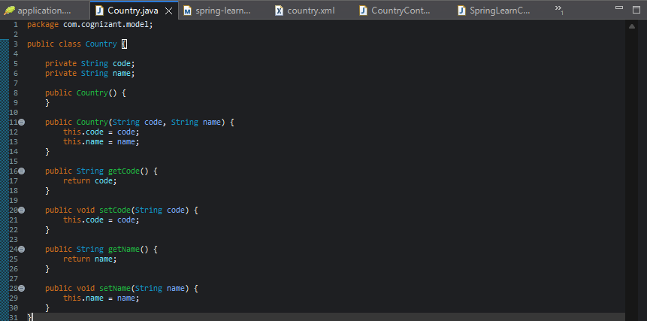
CountryService.java:
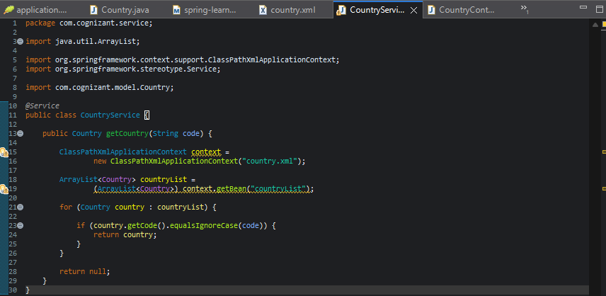

Output:
